MARK IOFFE

Does the Black-Scholes formula contain information regarding the rate of return
of the stock?

(Studies of Classics)

Abstract
It seems that vast popularity Black-Scholes formula has become primarily because it contains no assumptions about non-random, predictable the rate of return of the stock changing(“we do not require agreement on the expected returns on securities”, [2], page 400). Our analysis shows that according to the formula Black-Scholes average value of the rate of return of the stock, i.e. the mean value 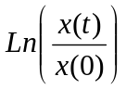 equal to the interest rate r that is not dependent on the characteristics of a particular stock. Thus, the model of the Black-Scholes has quite specific information about the rate of return of the stock.

It seems that vast popularity Black-Scholes formula has become primarily because it contains no assumptions about non-random, predictable the rate of return of the stock changing (“we do not require agreement on the expected returns on securities”, [2], page 400).
In deriving formula for the value of an option in terms of the price of the stock Black and Scholes assume following “ideal conditions” in the market for the stock and for the option [1]:
a) The short-term interest rate is known and is constant through time.
b) The stock price follows a random walk in continuous time with variance rate proportional to the square of the stock price. Thus the distribution of the possible stock prices at the end of any finite interval is lognormal. The variance rate of the return on the stock is constant.
c) The stock pays no dividends or other distributions.

d) The option is “European”, that is, it can only be exercised at maturity.
e) There are no transaction costs in buying or selling the stock or the options.
f) It is possible to borrow any fraction of the price of a security to buy or to hold it, at the short interest rate.
g) There are no penalties to short selling. A seller who does not own a security will simply accept the price of the security from a buyer, and will agree to settle with buyer on some future date by paying him an amount equal to the price of the security on the date.
If you make another additional assumption, namely that the price of European option equals the discounted expectation of payoff function at maturity, i.e. for Call 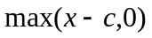, x stock price, c-strike price, then the above assumptions is sufficient to derive the formula for calculating price option.
Note that the authors [1] implicitly use this additional assumption in the derivation of the formula (4), using stochastic calculus. We consider two ways to derive the formula for calculating the option price, based on the above hypotheses. The first of these is similar to that described in [1] and is based on the known theory of stochastic diffusion processes.
Consider the log-normal distribution with two parameters, and m. Density distribution is equal
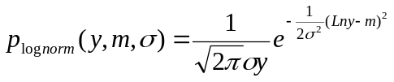
(1)

The first and second moments of this distribution equal

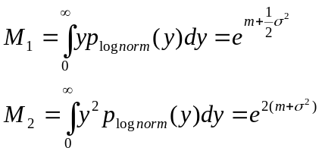
(2)

If the stock price is described by a geometric random walk in continuous time, the option price as a function of the current stock price x and time to maturity t, being the math. expectation satisfies the following equation
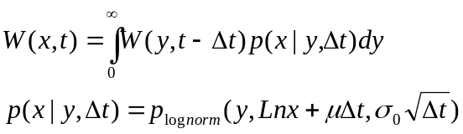
(3)
It follows from (2) and (3) the average price at the time of maturity equals

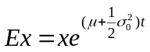
(4)
By Taylor's formula

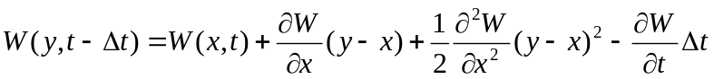
(5)
From formulas (2), (3) and (5) follows

(6)
We assume an infinitely small quantity and in formula (5) retain only the members up to the first order. The result

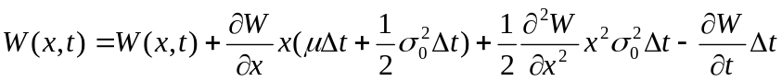
(7)
Thus, from (7) implies that the function 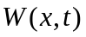 satisfies the parabolic equation:

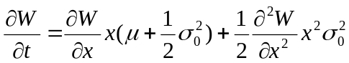
(8)

The initial condition for the Call option is obvious
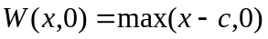
(9)
Where c-strike.
Equation (8) essentially simplified, that is reduced to an equation with constant coefficients, if you make the change of independent variable x to y by the formula
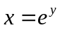
(10)
In this case, the equation (8) will
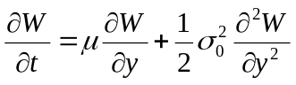
(9)
The corresponding initial condition is
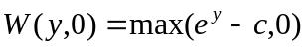
(10)

Solution of equation (9) with initial condition (10) has the form
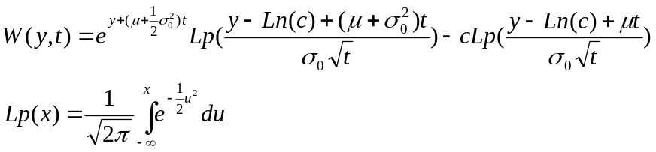
(11)
Option price equals the discounted value of the expectation, i.e.
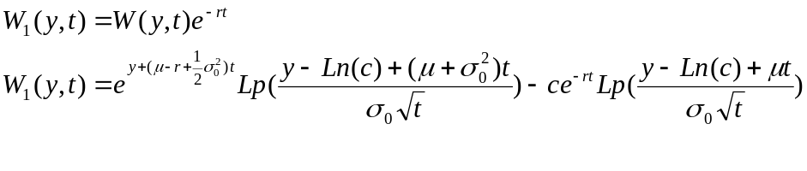
(12)
Where
r-riskless interest rate.
Second simpler and more obvious way of calculating the option price as the discounted math. expectation is the following formula.

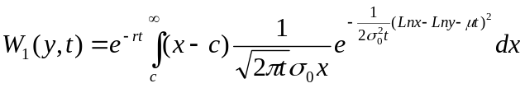
(13)
Calculation of the integral (13) leads to formula (12).
Option price formula (12) gets parameter, which is not in the corresponding formula of [1] (page 644, formula (13)). This parameter is one of the two parameters needed to describe a lognormal distribution, and characterizing the systematic component of the diffusion process describing the movement of the stock price.

The authors of [1] managed to exclude from consideration this parameter by considering a portfolio consisting of stock and a specified number of options (now called delta hedging). On the change of the price of the portfolio and on delta hedging value does not have effect. However, in the final formula for the price of the option is present.
Comparing our formula (1) and (13) on page 644 of [1], we find that the formulas coincide if and only if the parameter is equal
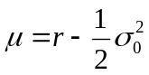
(14)
Note that the parameter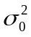 in our formula corresponds to the variance rate 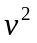in formula (13) [1].
From formulas (4) and (14) that according to the formula Black-Scholes average value of the rate of return of the stock, i.e. the mean value equal to the interest rate r, that is not dependent on the characteristics of a particular stock. Thus, the model of the Black-Schultz has quite specific information about the rate of return of the stock.

References
[1] Fisher Black, Myron Scholes. “The pricing of Options and Corporate Liabilities”
The Journal of Political Economy, Volume 81, Issue 3 (May-Jun., 1973), 637-654
[2] Fisher Black, Myron Scholes. The Valuation of Option Contracts and a Test of Market Efficiency.
The Journal of Finance, Vol. 27,No 2, Papers and Proceedings of the Thirtieth Annual Meeting of the American Finance Association, New Orleans, Louisiana, December 27-29, 1971 (May ,1972), pp 399-417.

